**Advance Operating Systems**

**Assignment-3**

**Due date: 10th April 2019**

**Question-1)** We want to look at some basic Docker commands and a simple build-ship-run workflow. We’ll start by running some simple containers, and then we’ll use a Dockerfile to build a custom app. Finally, we’ll look at how to use bind mounts to modify a running container as you might if you were actively developing using Docker. Go to the following online lab, "[Docker for Beginners"](https://training.play-with-docker.com/beginner-linux/).

**Note:** You are required to register for a free login that can be used to access Docker Cloud, Docker Store, and Docker Hub by visiting the site: [Docker Cloud](https://cloud.docker.com/)

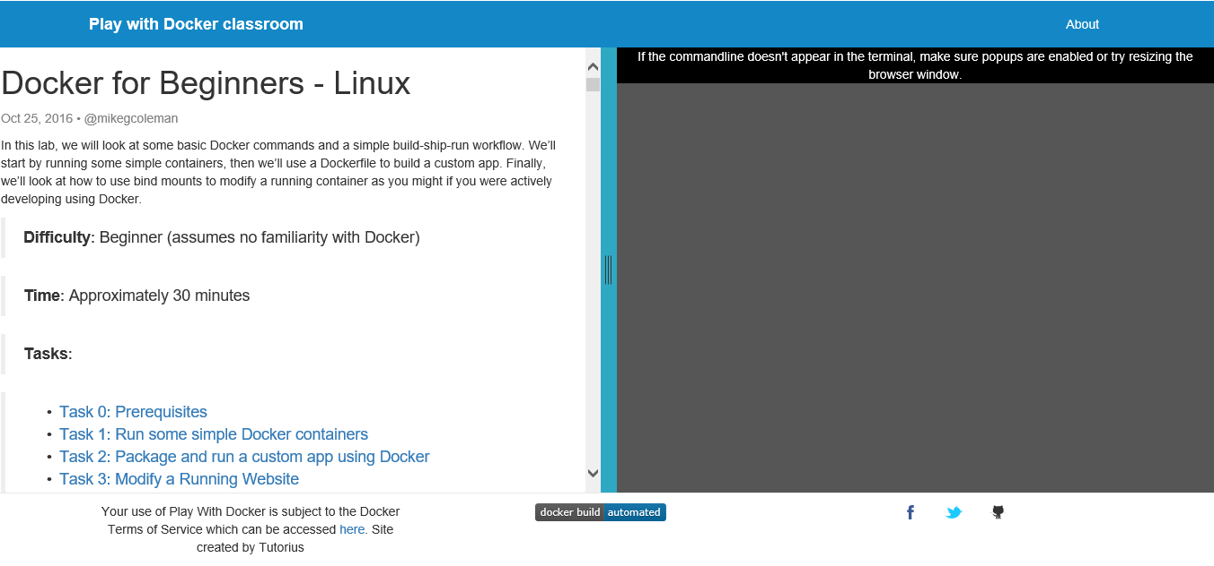

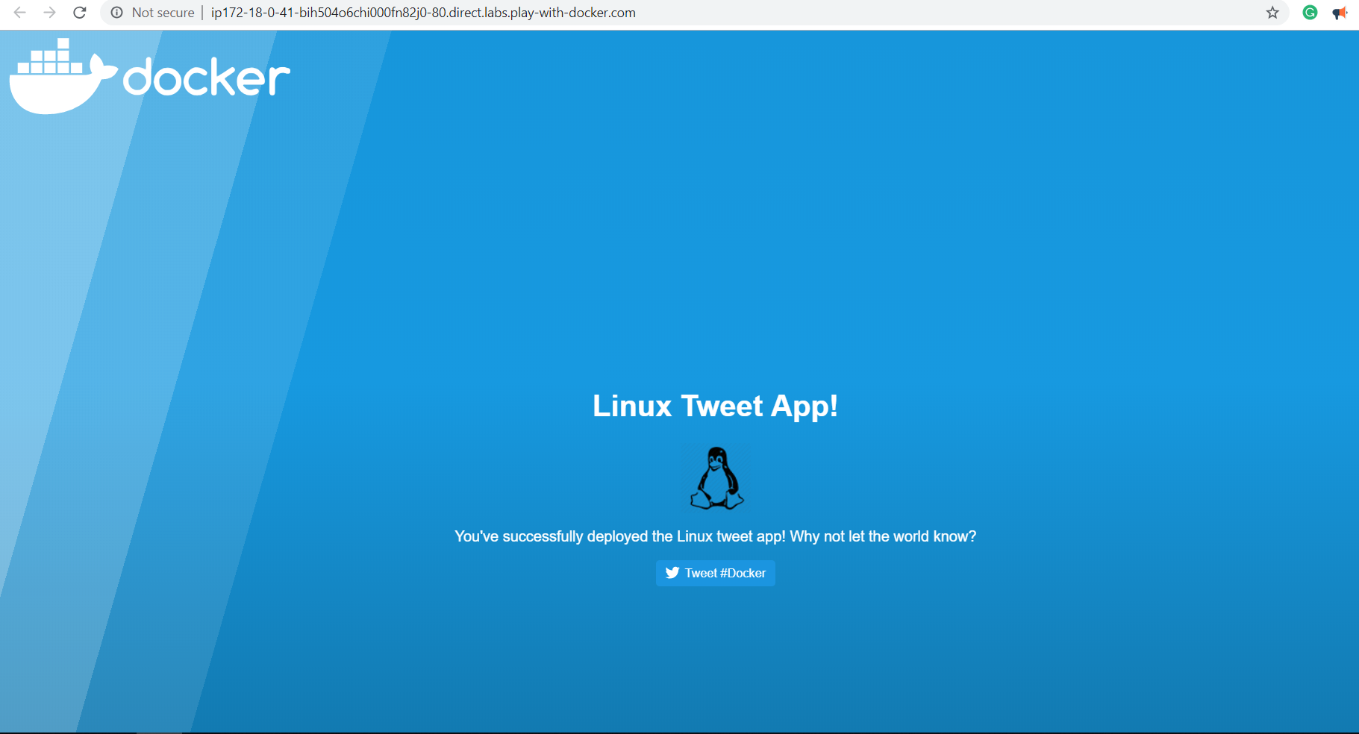

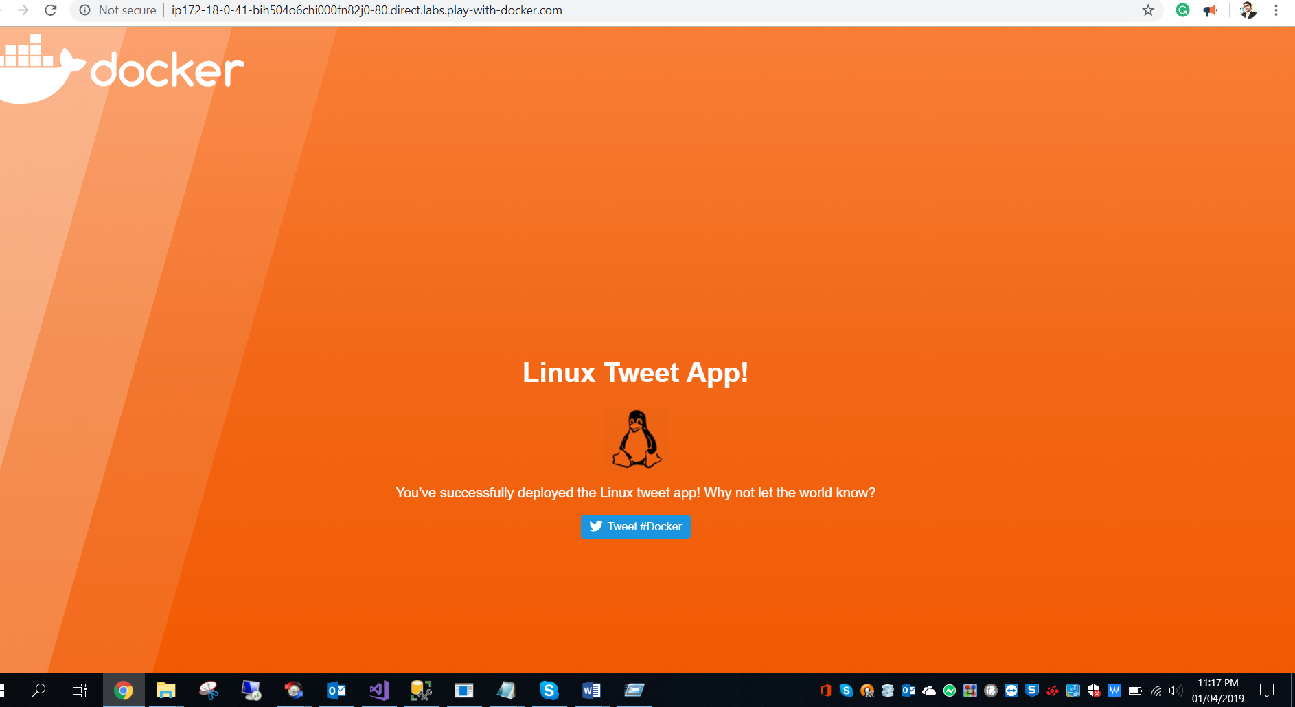

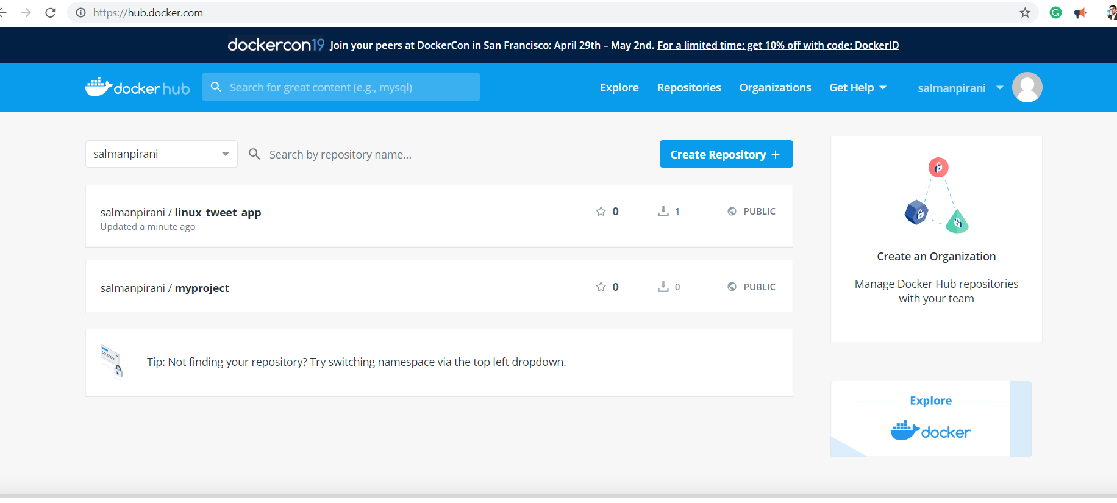

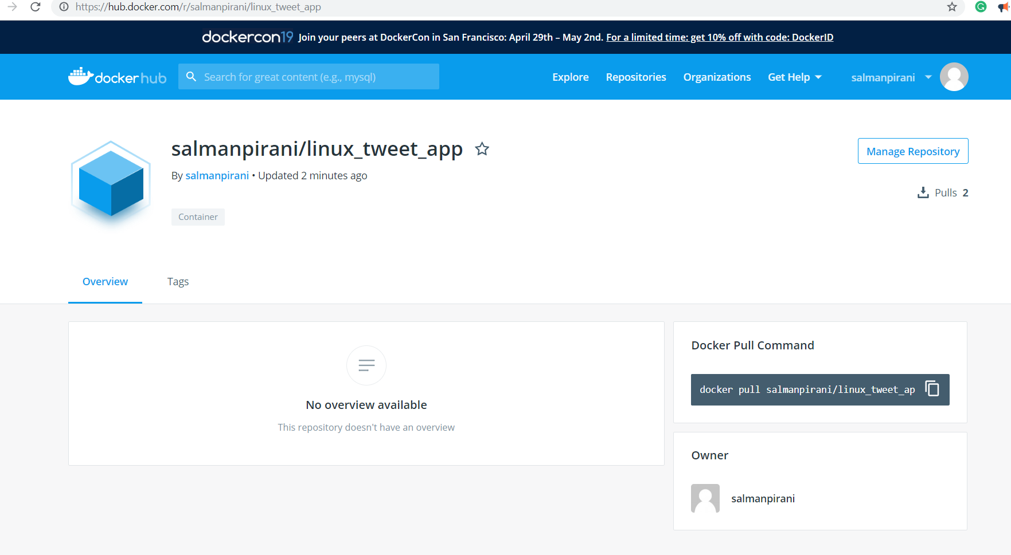

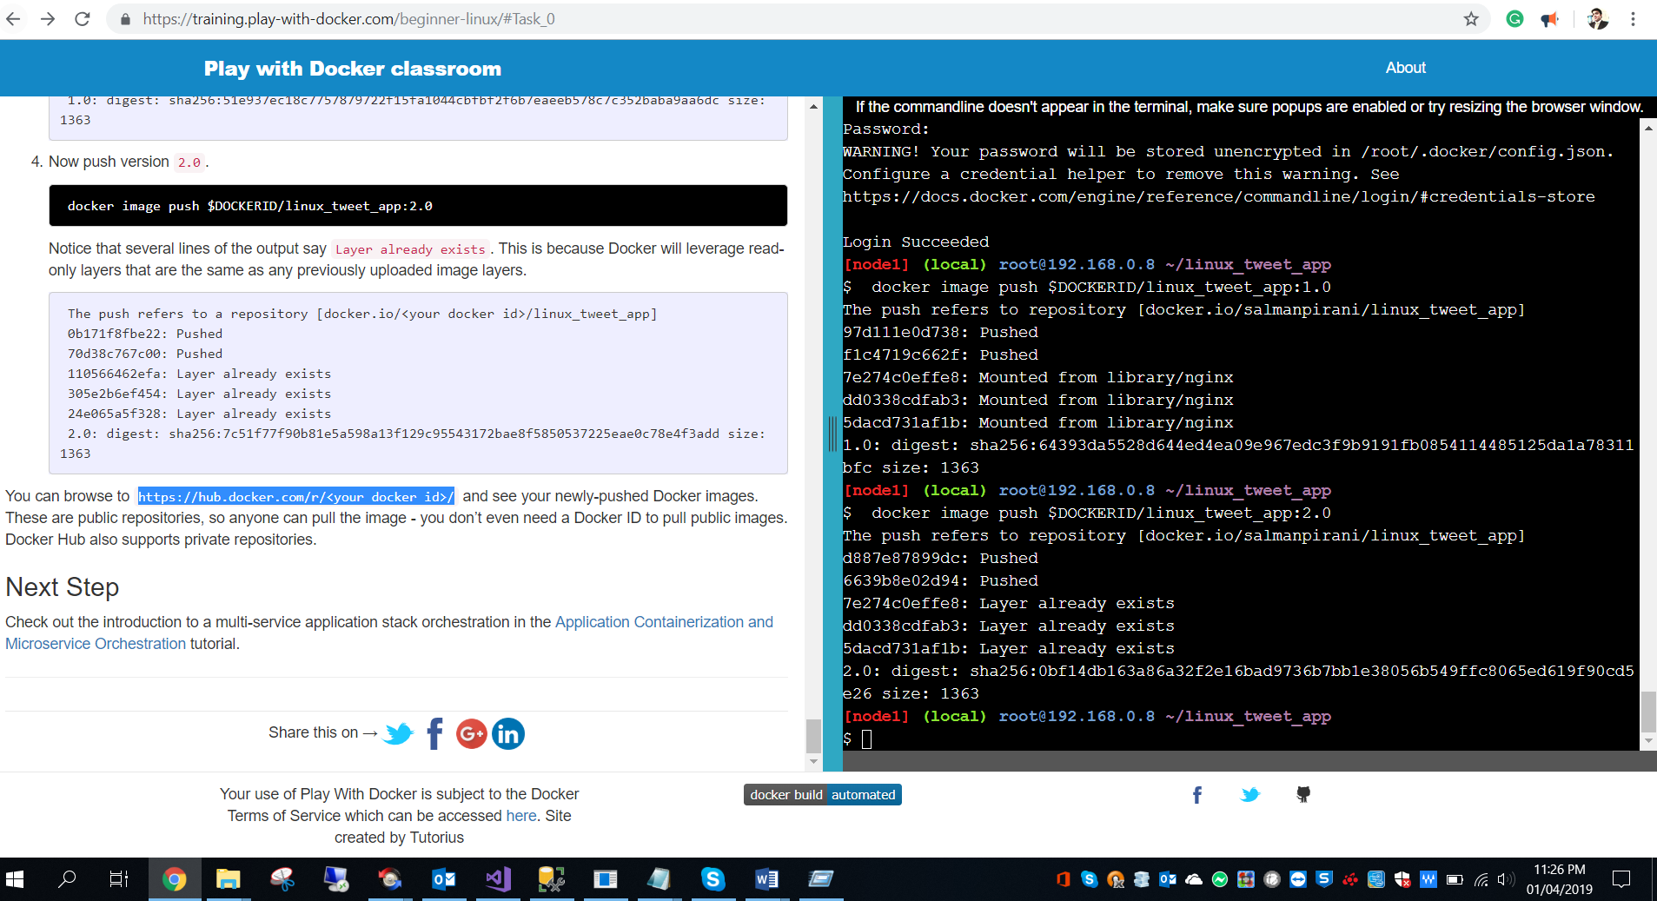

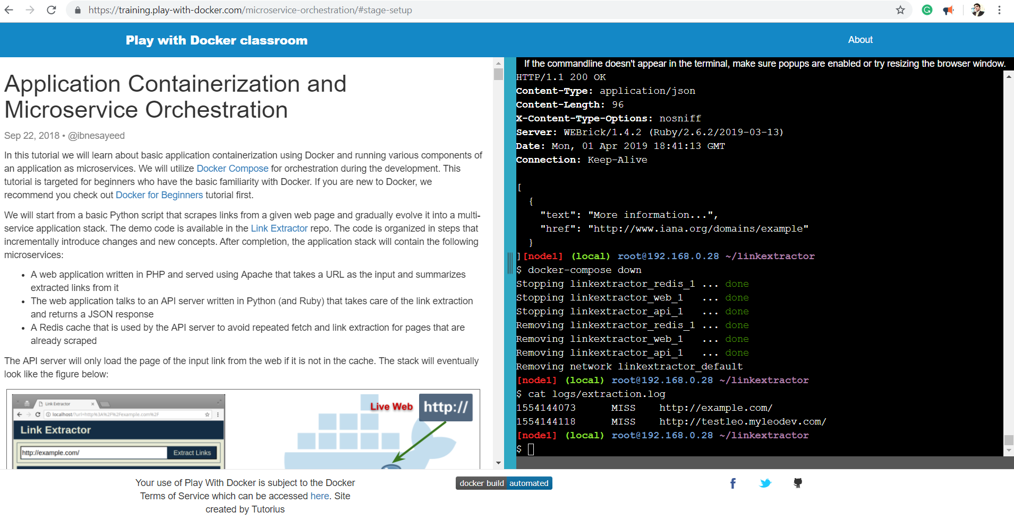

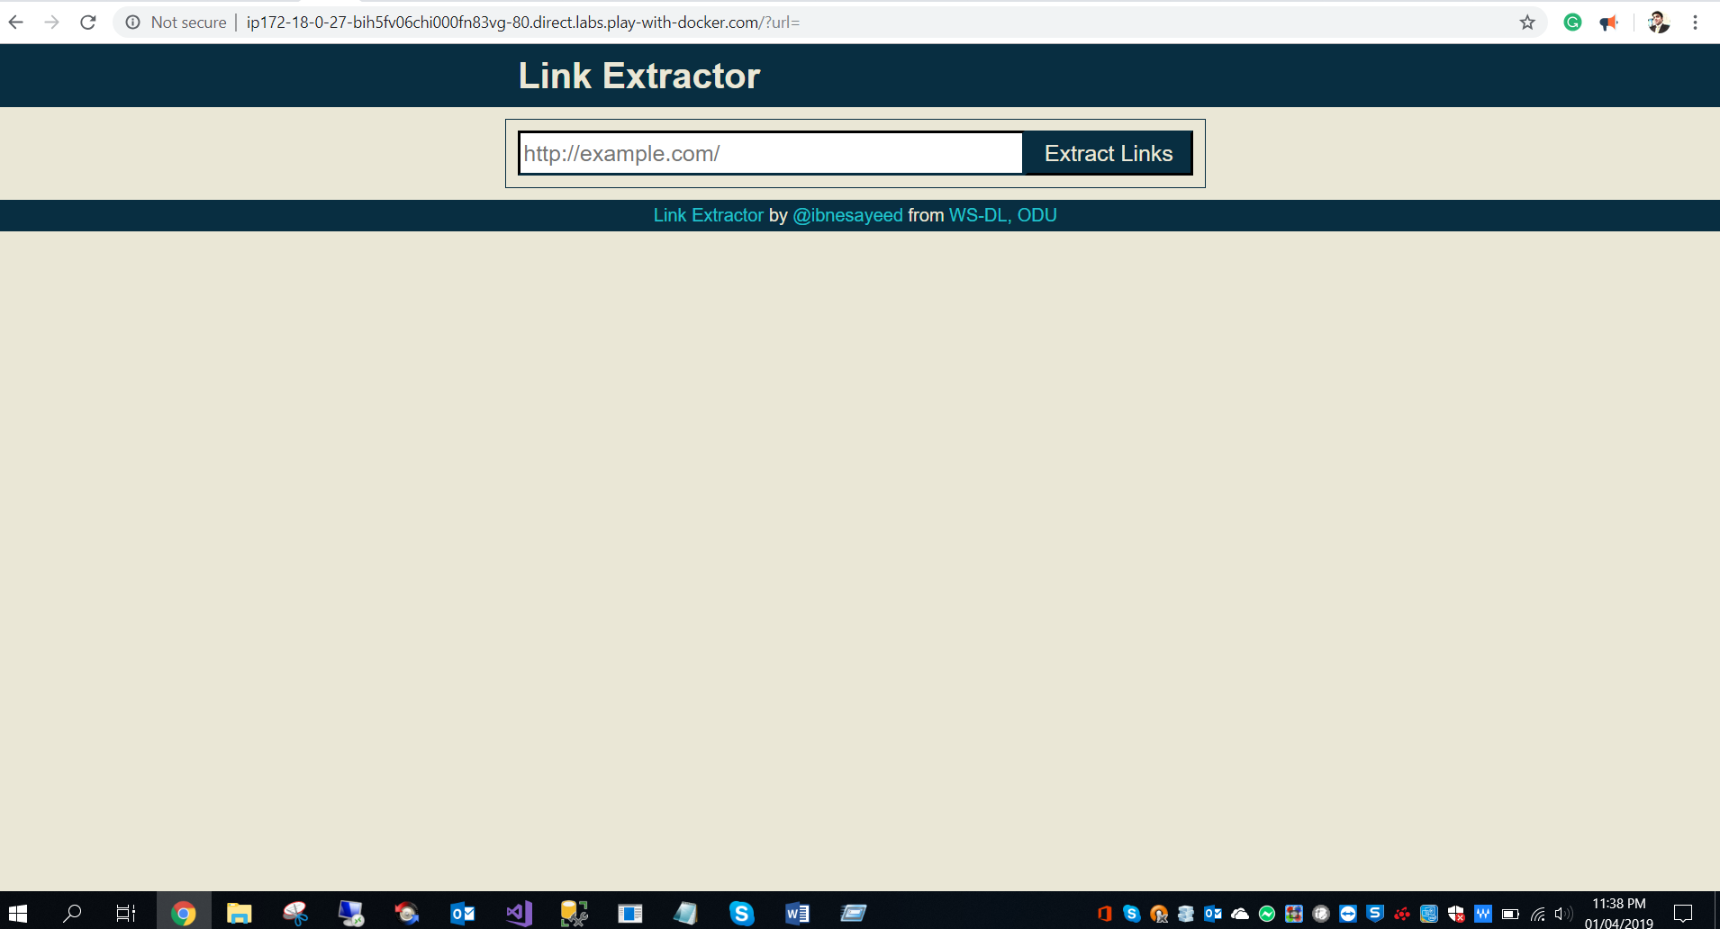

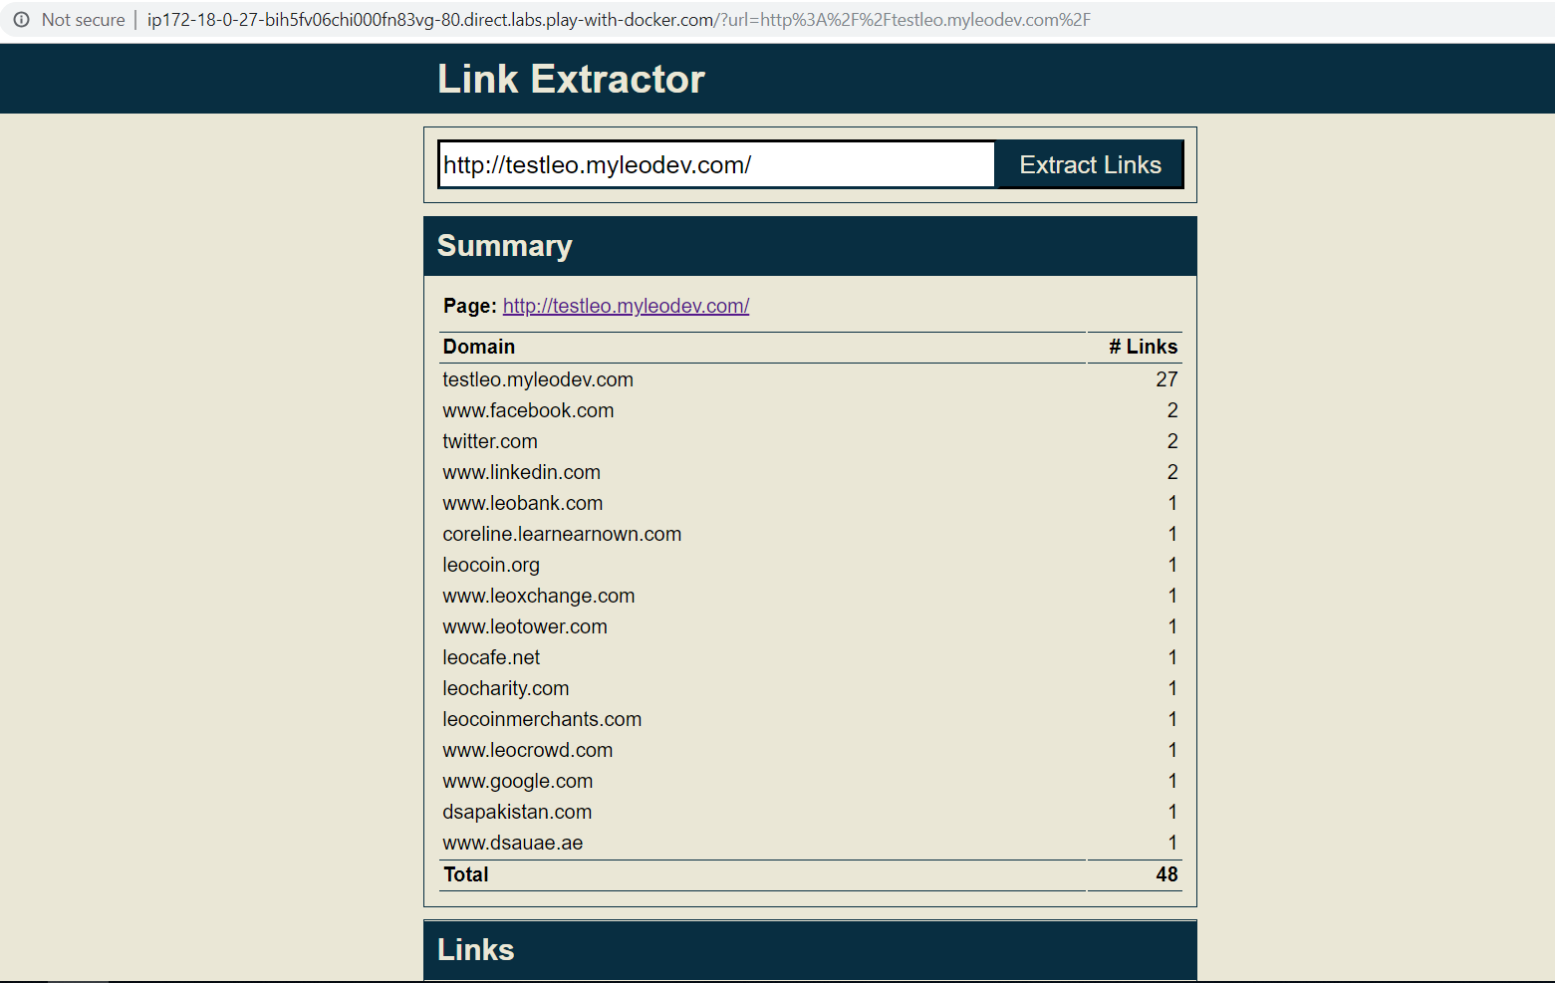

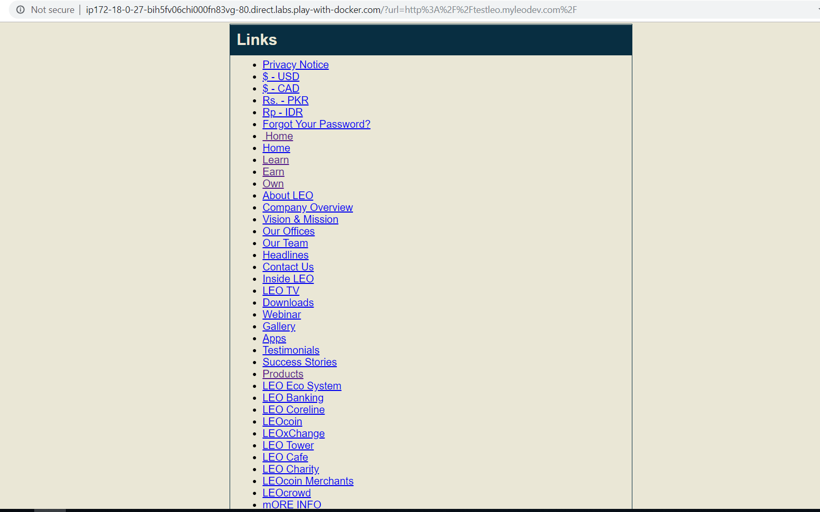

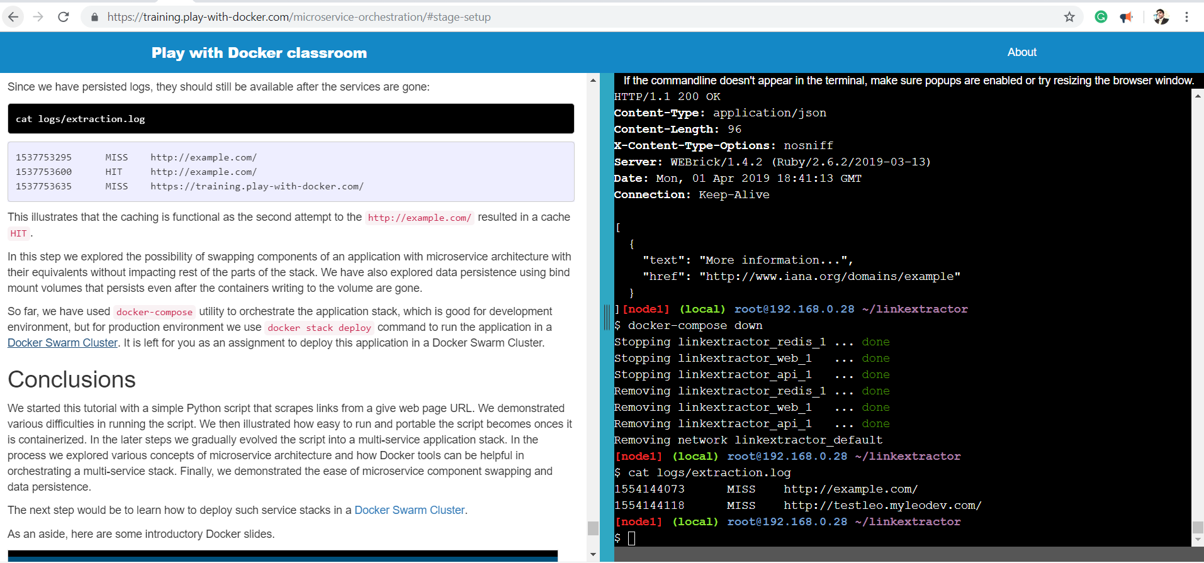

**Question2)** Now, using the new kernel, compile and test the simple "**first_mod**" kernel module. Create a new directory, and download both the .c source file and Makefile into that directory from the Assignment zip file. Change you name where my name is written. Also change printk message to include your name in it.

Compile the module using make and test it, by executing the following commands: ***insmod*** ***first_mod.ko***

Use ***lsmod*** command to list all the modules your module must be in the list.

(Look at the end of /var/log/syslog or at the end of the output of the command “dmesg” to see any module output.)  ***rmmod hello***

*After removing the module run the dmesg command again.*

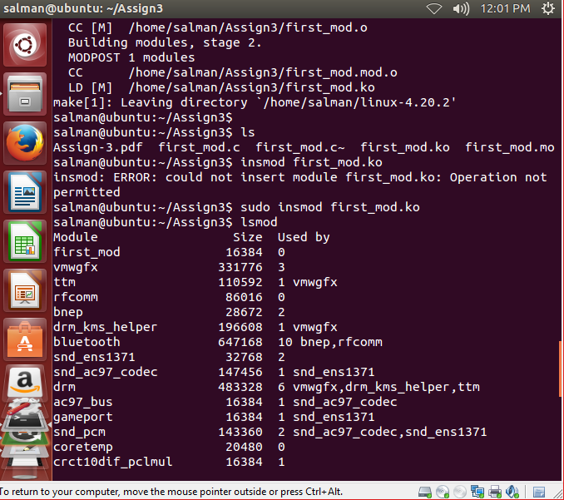

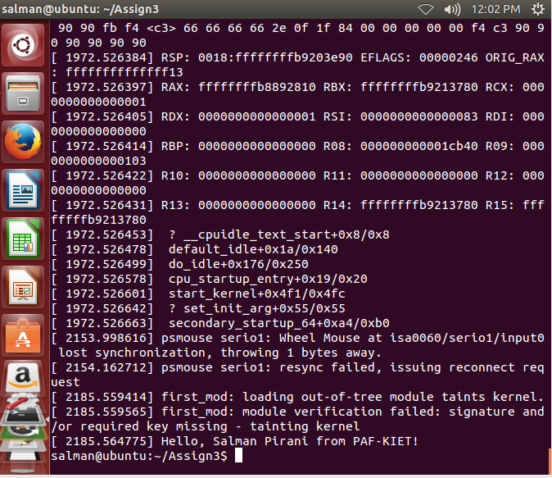

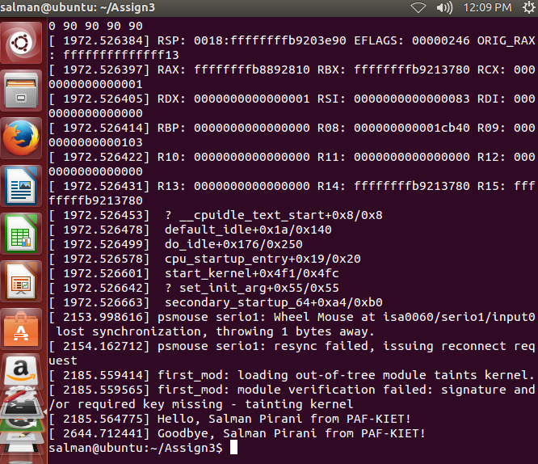

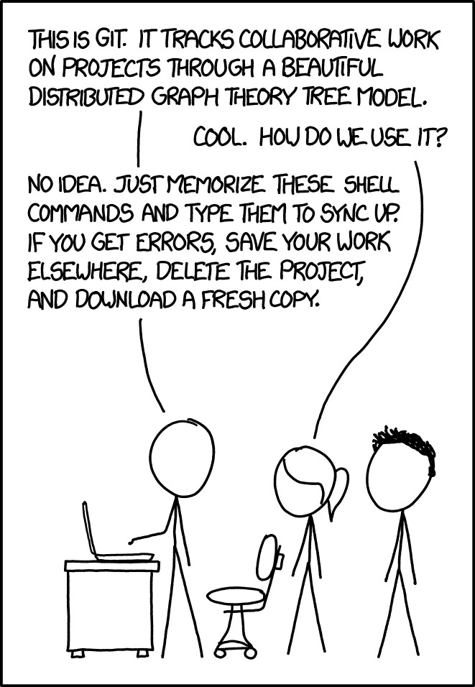

**Question-3:**

Watch this you video [“GitHub Desktop Quick Intro For Windows”](https://www.youtube.com/watch?v=77W2JSL7-r8) to get a quick

introduction of github. Then clone my project related to this course (https://github.com/kamran-nishat/AdvOS.git).

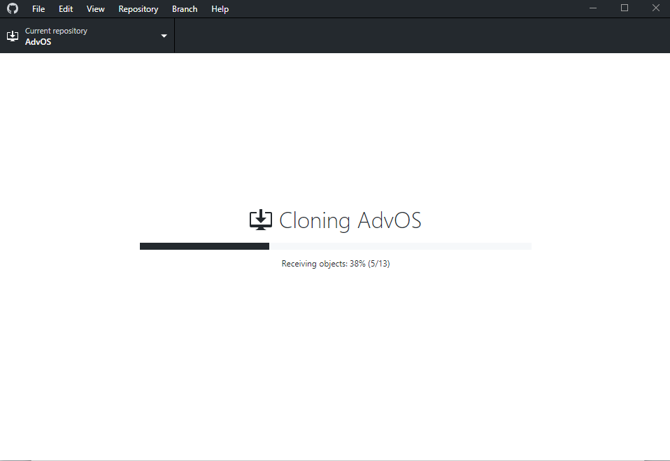

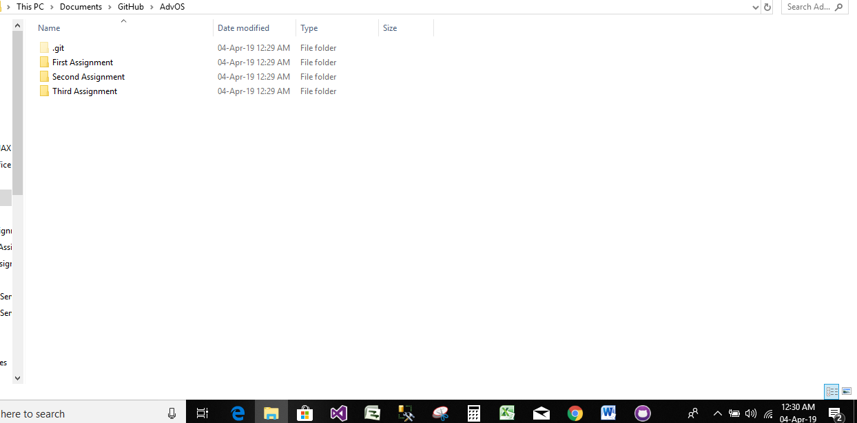 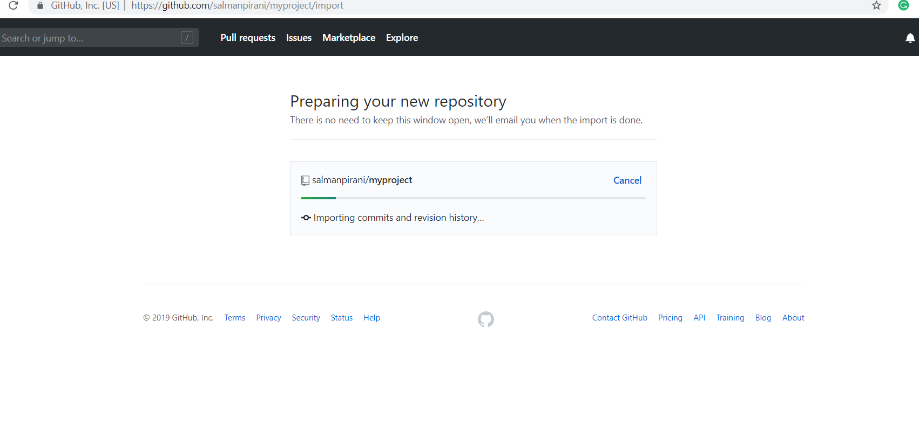

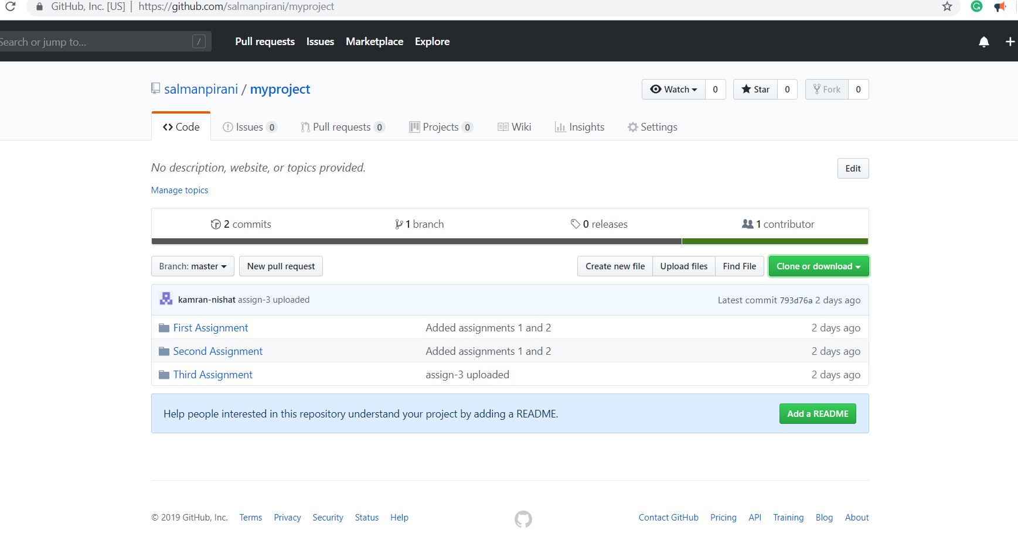

**Question-4:**

If you have a running Linux system with a working kernel, there are several places you can look for information about what devices you have, and what drivers are running. (***Note***: You need to run all these commands with ***sudo***)

○ Look at the system log file, ***/var/log/messages*** or use the command ***dmesg*** to see the messages printed out by the device drivers as they came up.

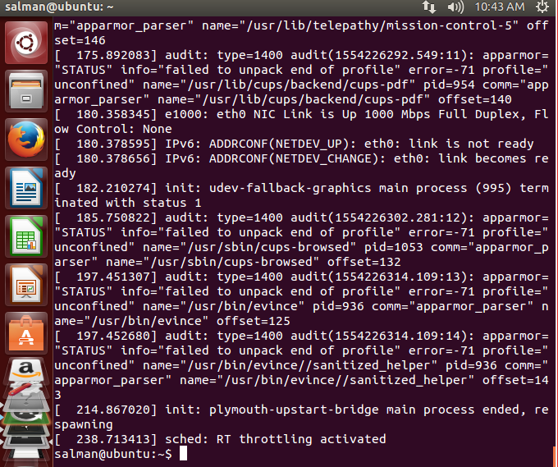

○ Use the command ***lspci -vv*** to list out the hardware devices that use the PCI bus.

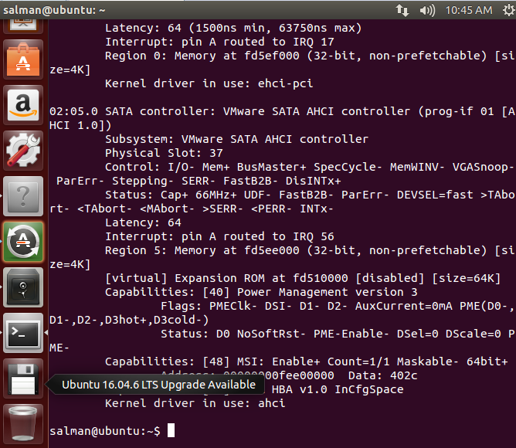

○ Use the command ***lsusb -vv*** to list out the hardware devices that use the USB.

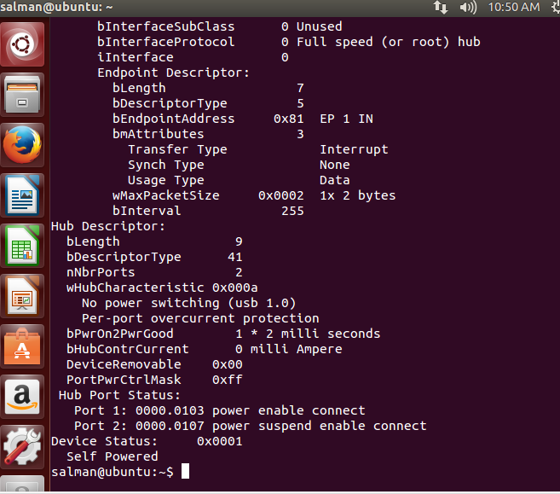

○ Use the command ***lsmod*** to see which kernel modules are in use.

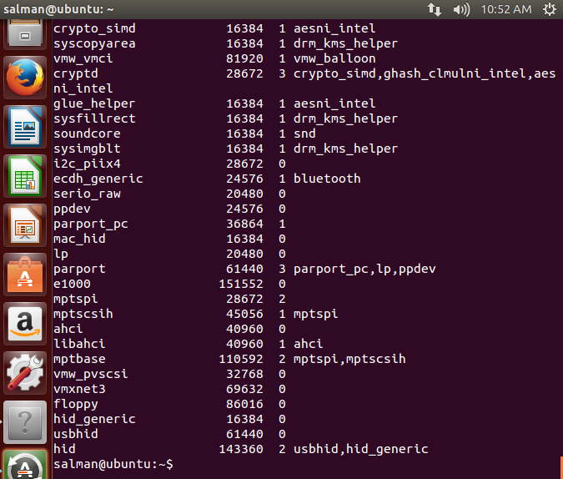

○ Look at ***/proc/modules*** to see another view of the modules that are in use.

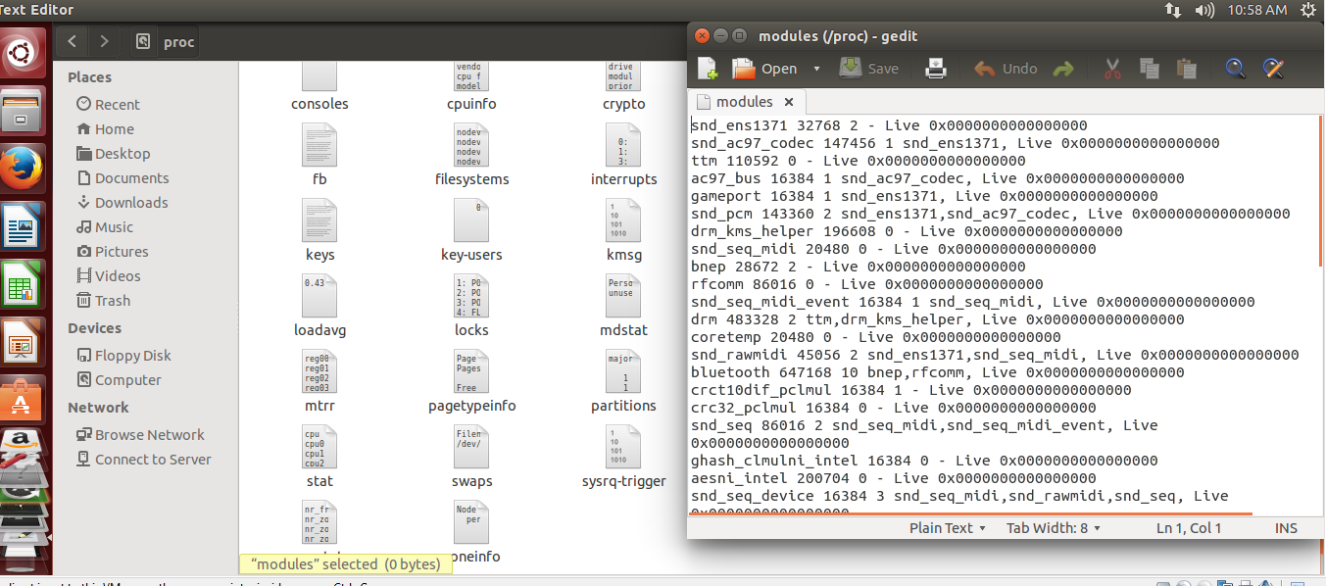

○ Look at ***/proc/devices*** to see devices the system has recognized.

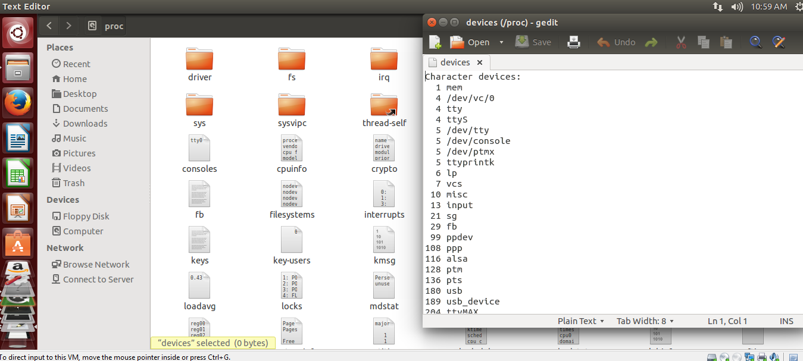

○ Look at ***/proc/cpuinfo*** to see what kind of CPU you have.

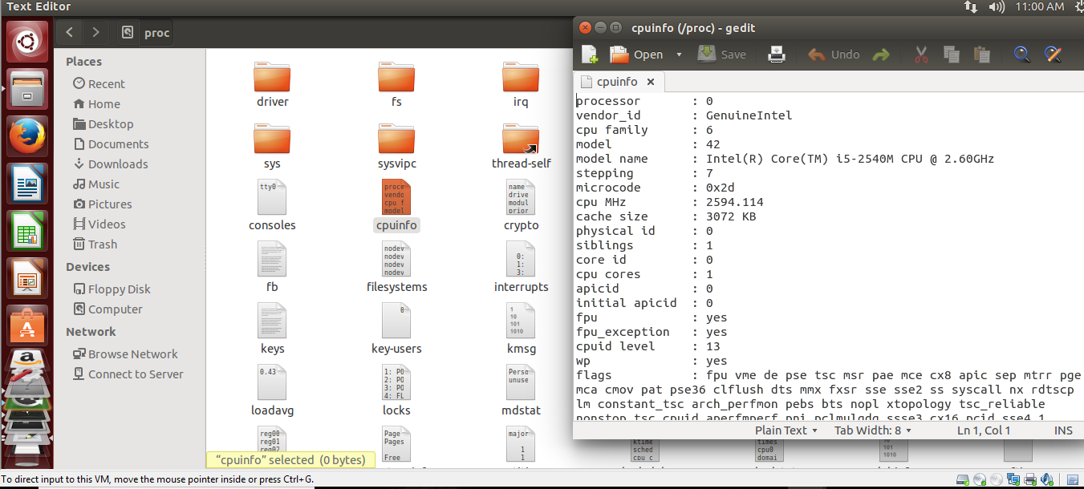

○ Look at ***/proc/meminfo*** to see how much memory you have.

